Practical Applications in Vegetation Management
Hosted by the SAF Coos Chapter

June 4, 2014 ● Mill Casino – North Bend, Oregon

This one-day workshop will focus on practical applications in managing forest vegetation. Speakers will address current issues, methods, and timelines in their presentations. Don’t miss this opportunity to pick up your Herbicide Applicator and SAF CFE credits. Actual credit hours will be available by May 23, 2014.

Wednesday, June 4 Workshop Agenda

8:30 am Welcome and Introduction—Tristan Huff, SAF Coos Chapter Member and OSU Extension Forester
8:45 Why Manage Competing Vegetation? Bruce Alber, Wilbur Ellis
9:15 Vegetation Management Timeline
• Pre-harvest—Jim Carr, The Campbell Group
• Site prep—Jim Carr
• Release—Speaker TBA
10:15 Morning Break
10:35 Mode of Action and Resistance—Andrew Hulting, OSU, and Bruce Kelpsas, Helena Chemical Co.
11:50 Luncheon Speaker: A Lifetime of Vegetation Management—Mike Newton, OSU
12:50 pm Neighbor Relations—Mark Gourley, Starker Forests
1:20 Drift Management—Bruce Alber
1:40 Safety in the Real World—John Burger, NWFF Environmental
2:10 Afternoon Break
2:30 Treatments for Preventing and Controlling Scotchbroom—Tim Harrington, US Forest Service
3:15 Controlling Gorse—Speaker TBA
3:35 How Much is Enough? The Economics in Vegetation Management—Steve Wickham, Plum Creek Timber (retired)
4:00 Wrap-Up—Tristan Huff
4:10 Adjourn

Registration Form
June 4, 2014 ● Mill Casino, North Bend, Oregon
Workshop registration includes all materials and catered lunch.

Name Daytime Phone
Organization Email
Address City, State, ZIP
Special Dietary Needs

Registration
□ Received by May 14: $75.00
□ Received by May 14: $90.00

Return completed registration form to:
SAF NW Office, 4033 SW Canyon Rd., Portland, OR 97221
fax 503-226-2515 • phone 503-224-8046 •
amanda@forestry.org

Method of Payment:
□ Check enclosed (payable to SAF Coos Chapter)
□ Purchase Order #:
□ Credit Card (Visa or MasterCard)
Account #
Expiration Date
Security Code
Location: The workshop will be held at Guerber Hall at the Benton County Fairgrounds, Corvallis. The Fairgrounds are located at 110 SW 53rd Street.

Workshop Information
Location: The workshop will be held at the Mill Casino, 3201 Treemont St., North Bend, OR 97420; http://www.themillcasino.com/.
Registration: The registration fee for the workshop is $75 if received by May 14 or $90 if received after May 14. The fee includes lunch and all materials. Checks should be made payable to SAF Coos Chapter. Purchase orders, Visa, and MasterCard are accepted. Tax ID #23-7065108. No refunds or cancellations after May 14, but substitutions are always welcome.
Herbicide Applicator and SAF CFE Credits: Credits will be available for both credits. Forms will be available at the registration desk.
Sponsors: The SAF Coos Chapter is sponsoring this workshop with Plum Creek Timber Company, Inc.
Questions? Registration questions can be directed to Amanda at 503-224-8046 or amanda@forestry.org. Program questions can be directed to Scott Nichols at 541-290-7266.

Practical Applications in Vegetation Management
June 3, 2014 ● Mill Casino, North Bend, Oregon

Sponsored by:

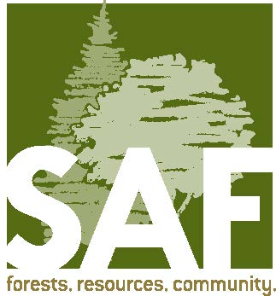

SAF Coos Chapter

